# Exercise: Object Composition

Problems for exercises and homework for the ["JavaScript Advanced" course @ SoftUni](https://softuni.bg/courses/js-advanced). Submit your solutions in the SoftUni judge system at <https://judge.softuni.bg/Contests/1546>.

## Heroes

Create a function **returns** an **object** with 2 methods (**mage** and **fighter**). This object should be able to **create** heroes (fighters and mages). Every hero has a **state**.

* Fighters have **name**, **health = 100** and **stamina = 100** and every fighter can fight. When he **fights** his **stamina** **decreases** by **1** and the following message is **printed** on the console:

**`${fighter's name} slashes at the foe!`**

* Mages also have state (**name**, **health = 100** and **mana = 100**). Every mage can **cast** **spells**. When a spell is casted the mage's **mana** **decreases** by **1** and the following message is **printed** on the console:

**`${mage's name} cast ${spell}`**

### Note:

For more information check the examples below.

|  |  |
| --- | --- |
| Input | Output |
| let create = solve();  const scorcher = create.mage("Scorcher");  scorcher.cast("fireball")  scorcher.cast("thunder")  scorcher.cast("light")  const scorcher2 = create.fighter("Scorcher 2");  scorcher2.fight()  console.log(scorcher2.stamina);  console.log(scorcher.mana); | **Scorcher cast fireball**  **Scorcher cast thunder**  **Scorcher cast light**  **Scorcher 2 slashes at the foe!**  **99**  **97** |

### Hints:

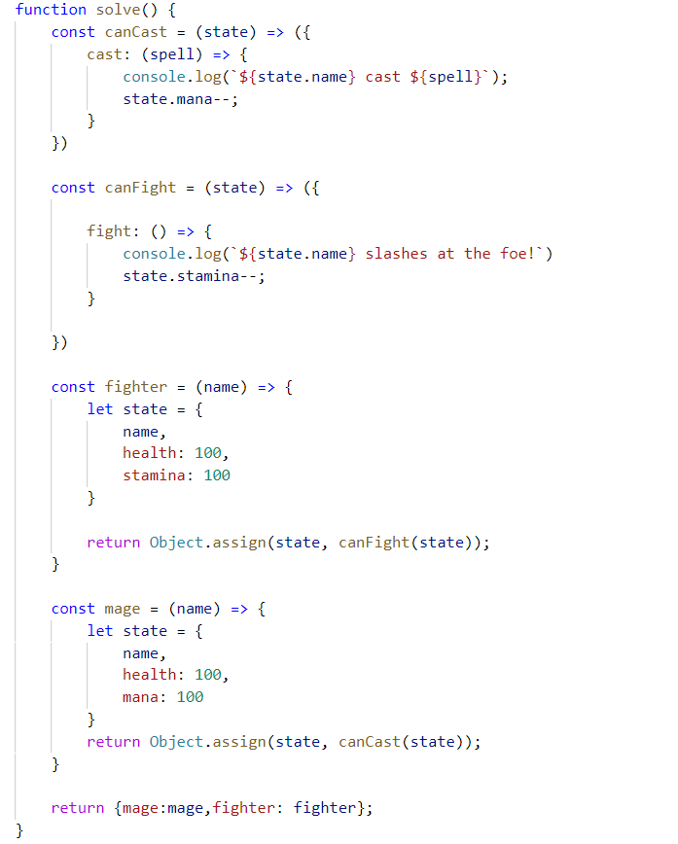

## Construction Crew

Write a program that **receives** a worker **object** as a **parameter** and modifies its properties. Workers have the following structure:

{ weight: Number,

experience: Number,

levelOfHydrated: Number,

dizziness: Boolean }

Weight is expressed in **kilograms**, **experience** in **years** and **levelOfHydrated** is in **milliliters**. If you receive a worker who’s **dizziness** property is set to **true** it means he needs to intake some **water** in order to be able to work correctly. The required amount is 0.1ml per **kilogram** per year of **experience**. The required amount must be **added** to the **existing amount**. Once the water is administered, change the **dizziness** property to **false**.

Workers who **do not have dizziness** should **not** be modified in any way. Return them as they were.

### Input

Your function will receive a valid **object** as **parameter**.

### Output

Return the **same object** that was passed in, **modified** as necessary.

### Examples

|  |  |
| --- | --- |
| Input | Output |
| { weight: 80,  experience: 1,  levelOfHydrated: 0,  dizziness: true } | { weight: 80,  experience: 1,  levelOfHydrated: 8,  dizziness: false } |
| { weight: 120,  experience: 20,  levelOfHydrated: 200,  dizziness: true } | { weight: 120,  experience: 20,  levelOfHydrated: 440,  dizziness: false } |
| { weight: 95,  experience: 3,  levelOfHydrated: 0,  dizziness: false } | { weight: 95,  experience: 3,  levelOfHydrated: 0,  dizziness: false } |

## Car Factory

Write a program that assembles a car by **given requirements** out of **existing** **components**. The client will place an order in the form of an **object describing** the car. You need to **determine** which parts to use to fulfil the client’s order. You have the following parts in storage:

An **engine** has **power** (given in horsepower) and **volume** (given in cubic centimeters). Both of these values are **numbers**. When selecting an engine, pick the **smallest possible** that still meets the requirements.

Small engine: { power: 90, volume: 1800 }

Normal engine: { power: 120, volume: 2400 }

Monster engine: { power: 200, volume: 3500 }

A **carriage** has a **type** and **color**. Both of these values are **strings**. You have two types of carriages in storage and can paint it **any color**.

Hatchback: { type: 'hatchback', color: <as required> }

Coupe: { type: 'coupe', color: <as required> }

The **wheels** will be represented by an **array** of 4 **numbers**, each number represents the **diameter** of the wheel in inches. The size can only be an **odd number**. Round **down** any requirements you receive to the nearest odd number.

### Input

You will receive an **object** as an **argument** to your function. The format will be as follows:

{ model: <model name>,

power: <minimum power>,

color: <color>,

carriage: <carriage type>,

wheelsize: <size> }

### Output

**Return** the resulting car **object** as a result of your function. See the examples for details.

### Examples

|  |  |
| --- | --- |
| Sample input | Output |
| { model: 'VW Golf II',  power: 90,  color: 'blue',  carriage: 'hatchback',  wheelsize: 14 } | { model: 'VW Golf II',  engine: { power: 90,  volume: 1800 },  carriage: { type: 'hatchback',  color: 'blue' },  wheels: [13, 13, 13, 13] } |
| { model: 'Opel Vectra',  power: 110,  color: 'grey',  carriage: 'coupe',  wheelsize: 17 } | { model: 'Opel Vectra',  engine: { power: 120,  volume: 2400 },  carriage: { type: 'coupe',  color: 'grey' },  wheels: [17, 17, 17, 17] } |

## Extensible Object

Create an object that can **clone** the **functionality** of another object into itself. Implement an extend(template) function that would copy all of the properties of **template** to the parent object and if the property is a function, add it to the object’s **prototype** instead.

### Input / Output

Your code should **return** the extensible **object instance**. The extend() function of your object will receive a valid object as **input parameter**, and has **no** output.

### Examples

|  |  |
| --- | --- |
| Extensible object | Resulting object |
| myObj: {  __proto__: {}  extend: function () {…}  } | myObj: {  __proto__: {  extensionMethod: function () {…}  },  extend: function () {…},  extensionProperty: 'someString'  } |
| Template object |
| template: {  extensionMethod: function () {…},  extensionProperty: 'someString'  } |

Note that **__proto__** is a hidden property, representing the object’s **prototype** - depending on your test environment, you may not have access to it directly, but you can use other functions to do that.

### Hints

To gain access to the prototype of an instance, use the **Object.getPrototypeOf()** function. To make a function shared between all instances, it’ll have to be attached to the prototype instead of the instance.

## String Extension

**Extend** the build-in String object with additional functionality. Implement the following functions:

* ensureStart(str) - append **str** to the beginning of a string, **only** if it’s **not** already present
* ensureEnd(str) - append **str** to the end of a string, **only** if it’s **not** already present
* isEmpty() - return **true** if the string is **empty**, **false** otherwise
* truncate(n) - truncates the string to **n** characters by **removing words** and appends an ellipsis (three periods) to the end. If a string is less than **n** characters long, return the **same string**. If it is longer, split the string where a **space** occurs and append an ellipsis to it so that the **total length** is less than or equal to **n**. If **no space** occurs anywhere in the string, return **n - 3** characters and an ellipsis. If **n** is less than 4, return **n** amount of periods.
* format(string, …params) - static method to replace placeholders with parameters. A placeholder is a number surrounded by curly braces. If parameter index cannot be found for a certain placeholder, do not modify it. Note static methods are attached to the **String object** instead of it’s prototype. See the examples for more info.

Note strings are **immutable**, so your functions will return new strings as a result.

### Input / Output

Your **main code** should be structured as an **IIFE** **without** **input or output** - it should **modify** the existing **String** **prototype** instead.

Input and output of the **extension functions** should be as described above.

### Examples

|  |  |
| --- | --- |
| Sample input | Value of *str* |
| let str = 'my string';  str = str.ensureStart('my');  str = str.ensureStart('hello ');  str = str.truncate(16);  str = str.truncate(14);  str = str.truncate(8);  str = str.truncate(4);  str = str.truncate(2);  str = String.format('The {0} {1} fox',  'quick', 'brown');  str = String.format('jumps {0} {1}',  'dog'); | 'my string' *// 'my' already present*  'hello my string'  'hello my string' *// length is 15*  'hello my...' *// length is 11*  'hello...'  'h...'  '..'  'The quick brown fox'  'jumps dog {1}' *// no parameter at 1* |

## *Sorted List

Implement a **collection**, which keeps a list of numbers, sorted in **ascending order**. It must support the following functionality:

* add(elemenent) - adds a new element to the collection
* remove(index) - removes the element at position **index**
* get(index) - returns the value of the element at position **index**
* size - number of elements stored in the collection

The **correct order** of the element must be kept **at all times**, regardless of which operation is called. **Removing** and **retrieving** elements **shouldn’t** work if the provided index points **outside the length** of the collection (either throw an error or do nothing). Note the **size** of the collection is **NOT** a function. Write your code such that the first function in your solution **returns an instance** of your Sorted List.

### Input / Output

All function that expect **input** as **parameters** will receive valid data. Any result expected from a function should be **returned** as it’s result. Your **main function** should **return** an **object** **instance** with the required functionality as it’s result.

## * Bug Tracker

Create a program for managing bug reports. It must perform as a self-contained module with exposed functionality. Whenever a new element is added, deleted or changed with a command, the HTML should be updated automatically. A bug report has the following structure:

{ ID: Number,

author: String,

description: String,

reproducible: Boolean,

severity: Number,

status: String }

The **ID** of each report has to be a **unique** number, starting from **zero** and increasing **sequentially**. The module needs to implement the following **functions**:

* report(author, description, reproducible, severity) - **create** a new bug report and store it. The ID is assigned automatically to the next available number and the **status** defaults to 'Open'
* setStatus(id, newStatus) - change the status of a bug registered in the system to newStatus by given ID
* remove(id) - delete a bug report by given ID
* sort(method) - change the order in which bug reports are displayed on the webpage. The method argument is a string and can be either 'author', 'severity' or 'ID'. Always sort in ascending order (default behavior for alphabetical sort). The default sorting method is by 'ID'.
* output(selector) - set the HTML element inside which the result is to be displayed to selector

Use the following structure for each HTML report:

|  |
| --- |
| index.html |
| <div id="report_${ID}" class="report">  <div class="body">  <p>${description}</p>  </div>  <div class="title">  <span class="author">Submitted by: ${author}</span>  <span class="status">${status} | ${severity}</span>  </div>  </div> |

### Input

Input will be passed to each applicable function as **parameters** in the correct format.

### Output

Your solution must **expose a module** with all required functions bundled in it (**return** it as a result of your main function). The **HTML** should be **modified** as specified.